**UDP**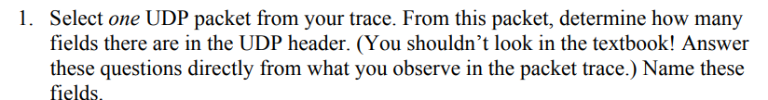

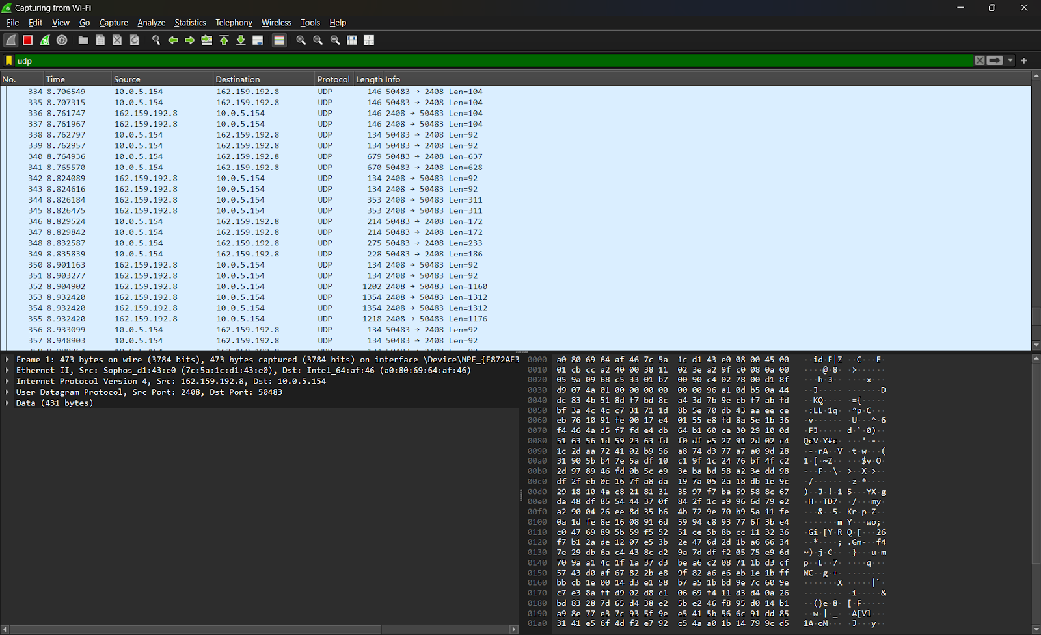

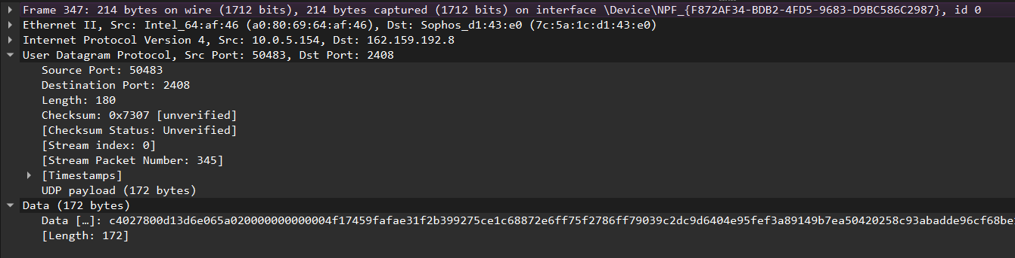



Each of the four fields in the UDP header is 2 bytes (16 bits) long.

Here’s the breakdown:

* **Source Port**: 2 bytes
* **Destination Port**: 2 bytes
* **Length**: 2 bytes
* **Checksum**: 2 bytes

So, the total UDP header length is 8 bytes.



The value in the Length field indicates the length of the entire UDP segment, which includes both the UDP header and the UDP payload.

The size of the UDP segment is: UDP Length=Header Length (8 bytes)+Payload Size

= 8 + 172

= 180

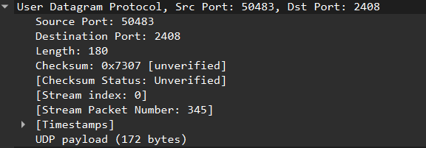



The maximum size of the Length field is 16 bits, meaning the maximum value it can hold is 65,535 (bytes). This includes both the UDP header (8 bytes) and the payload. Thus, the maximum payload size is:

Max Payload Size=65,535−8=65,527 bytes



The Source Port field is 16 bits, which means the maximum possible value is 2^{16}−1=65,535

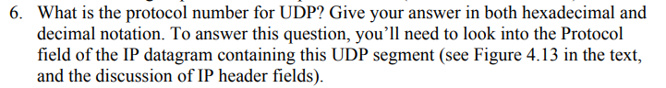

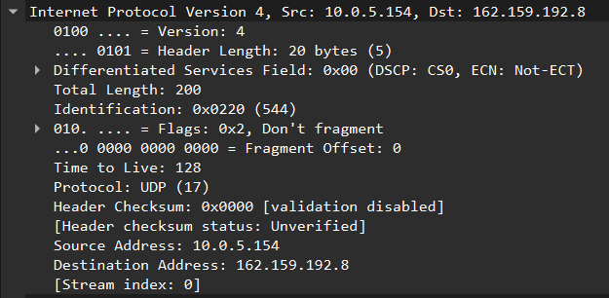

The protocol number for UDP is 17 (in decimal) or 0x11 (in hexadecimal).

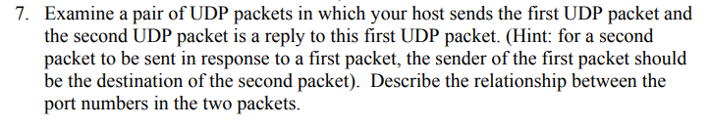

The relationship between the port numbers:

* The source port in the first packet becomes the destination port in the reply.
* The destination port in the first packet becomes the source port in the reply.

**TCP**

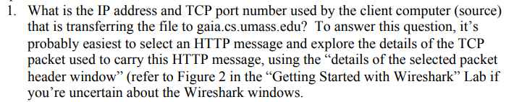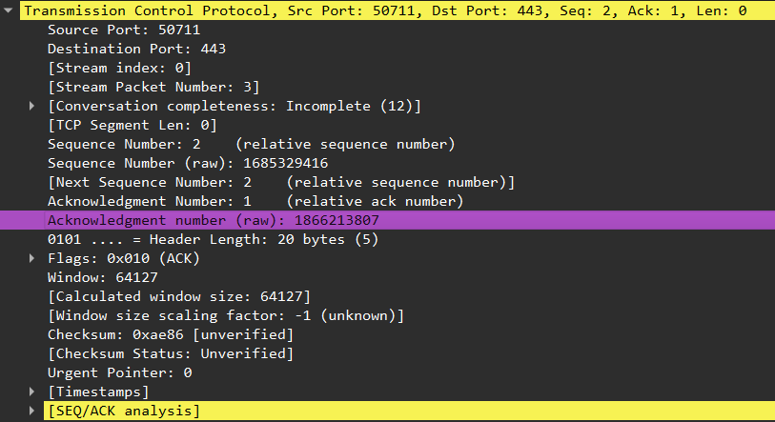

Source Port (Client): **50711**



Destination Port **: 443**



Source IP Address (Client): This is your local computer's IP address : **10.0.5.154**

Source Port (Client): This is the port number your client used **: 50711**

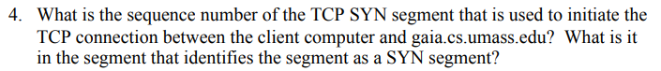

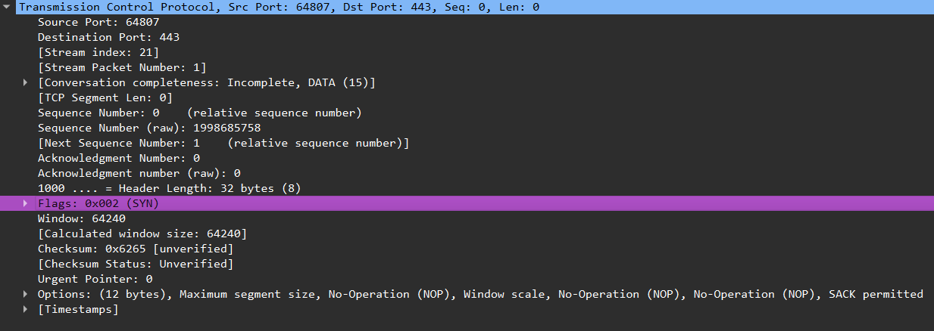

Sequence Number **: 1998685758**

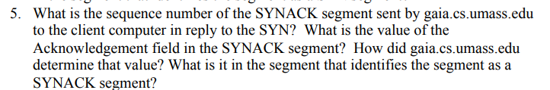

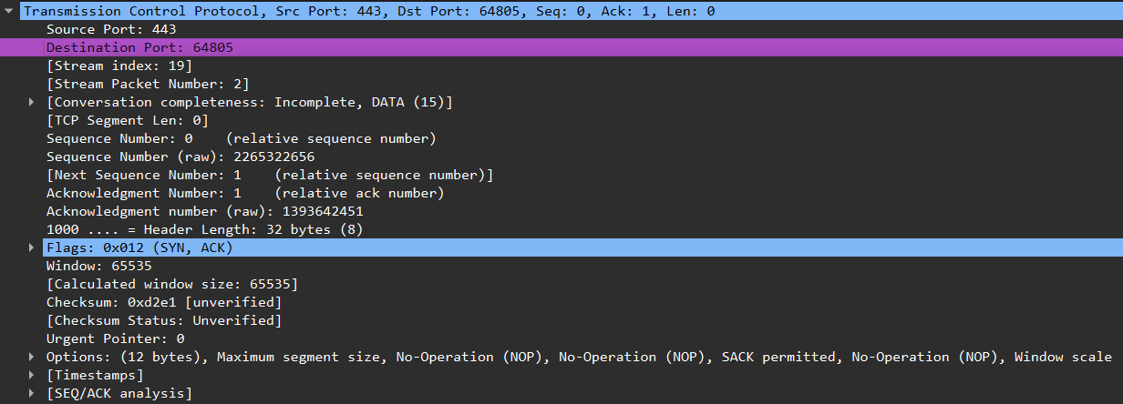

Sequence Number **: 2265322656**

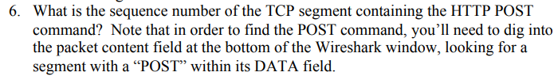



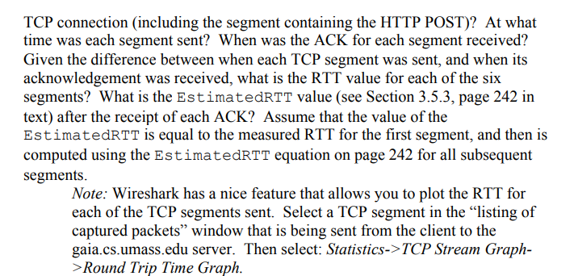



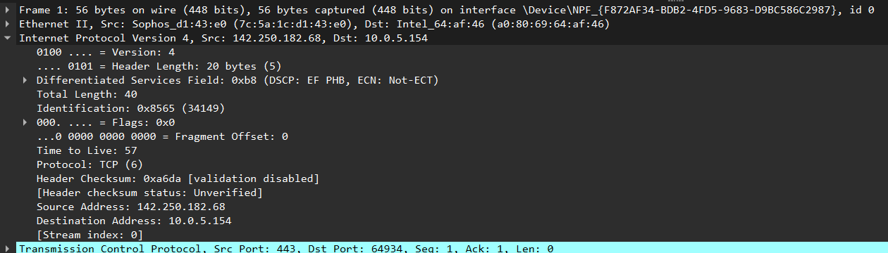

Length of each segment : **40**



The advertised window size here is 64127 bytes, which tells the sender the available buffer space on the receiver’s side. If this is the minimum window size observed in the trace, it would be your answer for the minimum buffer space.

Since the window size is non-zero, there is no immediate indication of throttling.



This packet does not appear to be a retransmission, as it’s labeled with an ACK flag and has no indicators of retransmission in the [SEQ/ACK analysis] section.

**SSL**

1. Capturing packets in an SSL session

